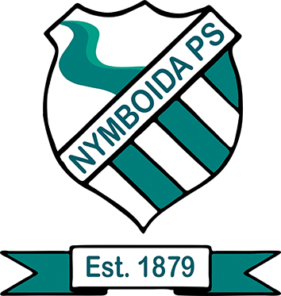
NYMBOIDA PUBLIC SCHOOL

DISCIPLINE POLICY 2020

- Statement of purpose
- Aims
- The core rules
- School rules
- Strategies to promote positive student behaviour
- Recognising and reinforcing achievement
- Strategies to manage inappropriate student behaviour
- Responsibilities
- Revision /evaluation

STATEMENT OF PURPOSE

The Discipline Policy at Nymboida Public School (NPS) ensures the foundation for a safe, happy and productive school environment.

Our discipline policy sets out a balanced approach recognising student achievement and dealing with unacceptable behaviour. It is based on developing student responsibilities, encouraging respect and creating good conditions for effective teaching and learning.

AIMS
1. To reflect the Core Rules in NSW Government Schools (2006): (regular attendance; adhering to the school’s uniform policy; behaving safely, considerately & responsibly; showing respect; caring for property).
2. To reflect the Values in NSW Public Schools (2004): (integrity, excellence, respect, responsibility, care, cooperation, participation, fairness & democracy).
3. To reflect the Anti-discrimination Act & its mandate of inclusivity.
4. To reflect the school’s Anti-Bullying, Attendance, Uniform within our Student Welfare framework.

THE CORE RULES

All students in NSW Government schools are expected to:
- Attend every school day, unless they are legally excused, and be in class on time and prepared to learn.
- Maintain a neat appearance, including adhering to the requirements of the school’s uniform or dress code policy.
- Behave safely, considerately and responsibly, including when travelling to and from school.
- Show respect at all times for teachers, other school staff and helpers, including following class rules, speaking courteously and cooperating with instructions and learning activities.
- Treat one another with dignity and respect.
- Care for property belonging to themselves, the school and others.
Behaviour that infringes on the safety of others, such as harassment, bullying and illegal or anti‐social behaviour, of any kind, will not be tolerated.

SCHOOL RULES

NPS rules have been refined to reflect both the school’s needs & the Core Rules of all NSW Government Schools.
OUR PBL values are: Be Respectful, Be Responsible and Be Safe

In the classroom we have the following rules to establish and support a positive and effective learning space:
- We keep our hands and feet to ourselves
- We follow Instructions
- We walk in the room
- We have a go and stay on task
- On the floor we do the 6 L’s (learning, Listening, looking, lips closed, legs crossed, lap is where hands go)
- We speak politely to everyone

In the playground we:
- We play fairly and safely
- We show good sportsmanship
- We look after our equipment
- stay in the appropriate playing areas (not out-of-bounds)
- follow directions
- We keep our hands and feet to ourselves
- We speak politely to everyone

STRATEGIES TO PROMOTE POSITIVE STUDENT BEHAVIOUR

At NPS the fostering of positive behaviour is at the core of all teaching and learning programs and practices. Strategies are constantly reviewed and refined to reflect the students’ needs.

In the classroom we use Dojo points to encourage a positive learning environment.
ClassDojo is a communication app for the classroom. It connects teachers, parents, and students who use it to share photos, videos, and messages through the school day. They use ClassDojo to work together as a team, share in the classroom experience, and bring big ideas to life in their classrooms and homes.
Classroom Dojo is where teachers and students build their classroom culture. They choose skills and values – things like creativity or teamwork – and share feedback on progress with each other. Classroom Dojo is the simplest way for teachers and students to build an incredible classroom culture together.

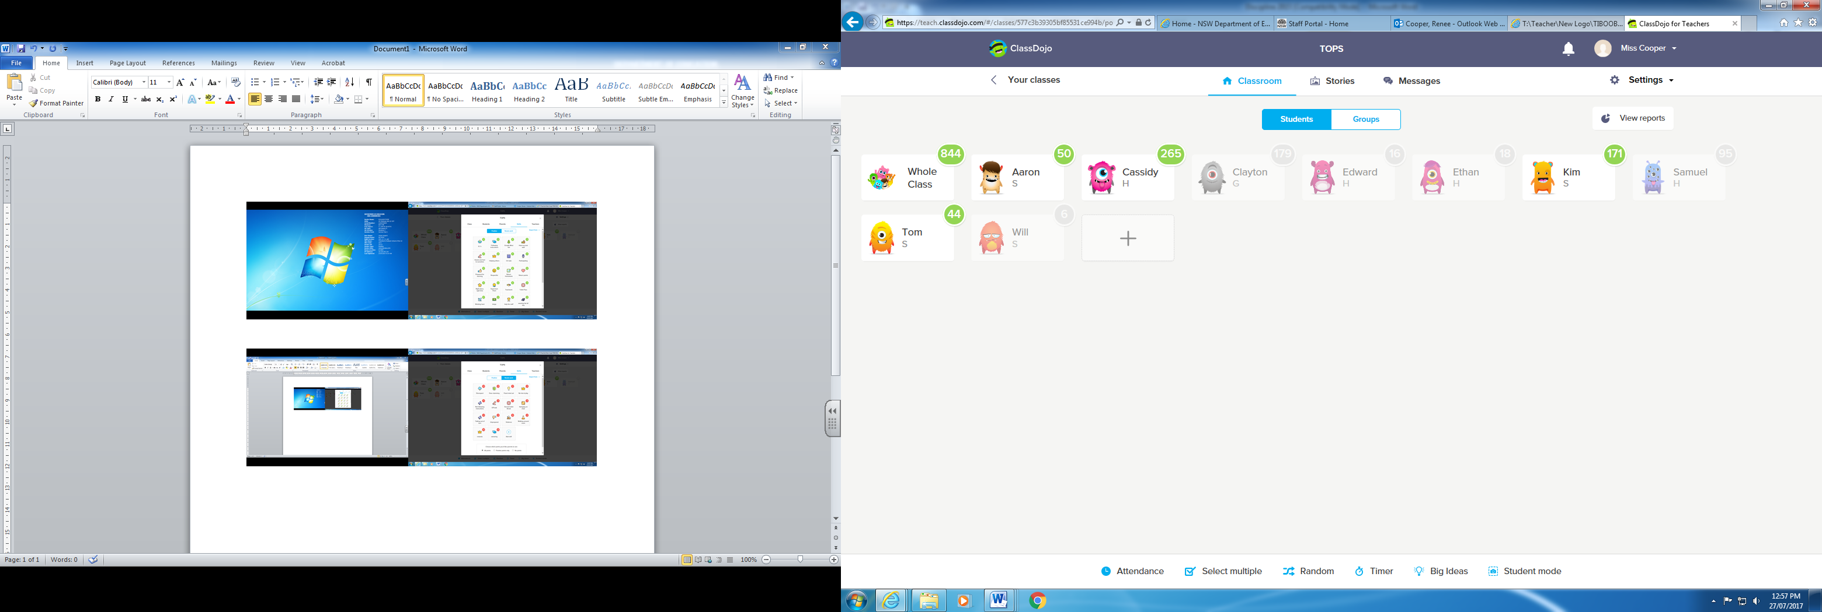

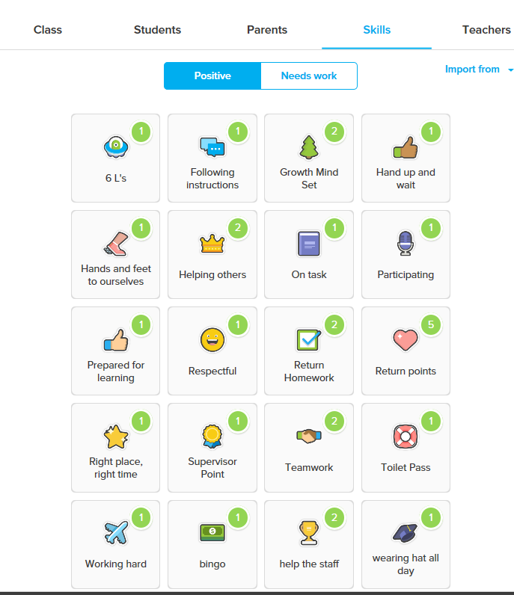

The students in conjunction with the teacher have set up target to achieve in their classroom to receive a set award/reward. These are changed each Term in conjunction with the classrooms discussion around dojo rewards.

RECOGNISING AND REINFORCING ACHIEVEMENT

The recognition of students’ achievements is central to ensuring the effectiveness of the strategies in place. At NPS we recognise and reinforce achievements through class discussions that identify what students have achieved and demonstrated (building peer support) and awards presented at assembly for having achieved behaviour or learning milestones.

STRATEGIES TO MANAGE INNAPROPRIATE STUDENT BEHAVIOUR

Inappropriate behaviour is that which disrupts the learning environment; it interrupts teaching and learning time.

Time out, detention and conversations are used with the teacher for consistent inappropriate behaviour.

There are some instances of behaviour which are unacceptable and will not be subject to this system. Unacceptable behaviour includes:

- violence or threats of violence
- possession of illegal drugs
- possession of offensive weapons
- persistent disobedience
- criminal behaviour

The Principal will suspend, consistent with procedures, any student engaging in these offences. In the most extreme cases, students will be expelled.

RESPONSIBILITIES

Parents/caregivers are in a position to set the best examples of positive behaviour for their children. We strongly encourage parents and caregivers to regularly reinforce respect for others at home, at school and in the community. At NPS we encourage parents to work in a positive partnership with students and staff in order to reinforce the school’s rules and values at home.

We strongly believe every student has the right to a learning environment free from bullying and intimidation and to feel safe and happy at school. They have a right to be treated fairly and with dignity. The same rights apply to teachers as the school is their workplace.

Our students are expected to uphold our rules in classrooms, on the playground, when representing the school on excursions throughout all times of any school day.

Our staff are expected to always act as good role models for students and ensure that school rules are upheld consistently. The staff of NPS will be exemplary professionals who strive for continual school improvement by always acting responsibly according to the department Code of Conduct (2020).

REVISION

Our Discipline Policy will be reviewed on an annual basis.
- A list of suggestions/issues will be kept throughout the year to refine the policy.
- The Discipline Policy will be reviewed at a suitable P and C meeting for the year.
- A copy of the policy is available on request from the school office.

