
NYMBOIDA PUBLIC SCHOOL

SCHOOL ATTENDANCE POLICY 2020

RATIONALE
Regular attendance at school is fundamental to success and well being of students. It is the responsibility of the parents to ensure students attend school on a regular basis, however, it is the schools responsibility to monitor attendance and actively engage in supporting and assisting parents to get students to attend school. The school will be engaging in regular evaluations and improvement of roll marking and attendance monitoring procedures in an endeavour to reduce the rates of absenteeism. Through the use of the HSLO/ASLO and staff training and development the school hopes to support the parent body to the best of its ability in responding quickly and effectively to support students with attendance issues.

Due to the small number of students at the school and the close working relationship with all families any absences are usually notified by parents on the day or prior to the absence. Exception forms will be used by families in line with DEC policies. The principal is in regular contact with all families and will work closely with all families to maintain attendance.

DET POLICY STATEMENT / THE LAW

- Section 22 of the Education Act (1990) states that it is the duty of the parent of a child of compulsory school age to cause the child:
- to be enrolled at, and to attend, a government school or a registered non-government school, or
- be registered for home schooling with the Board of Studies and to receive instruction in accordance with the conditions to which the registration is subject.
- All students who are enrolled at school, regardless of their age, are expected to attend that school whenever instruction is provided.
- Section 24 of the Act requires principals to maintain an attendance register (roll) in a form approved by the Minister. Attendance registers must be made available for inspection during school hours by a Board inspector or by any authorised person.

AIMS

- To promote regular student attendance and punctual arrival to school.
- To ensure accurate attendance registers are maintained
- To act promptly in the follow up of absences
- To refer individual cases to Home School Liaison Officer (HSLO) if necessary.
- To develop and monitor attendance improvement plans, if required, in consultation with parents
/carers/student/ district HSLO

RESPONSIBILITIES

Parents/Guardians must ensure:

- their children of compulsory school age are enrolled in a government or registered non- government school, or registered with the Board of Studies for Home Schooling.
- their children who are enrolled at school attend every day the school is open for instruction.
- they provide an explanation for absences to the school within 7 days from the first day of any period of absence through means such as a telephone call, written note or email. The 7 day timeframe for explaining absences is a requirement of the Education Act (1990).
- they work in partnership with the school to plan and implement strategies to support regular attendance at school. This includes communicating with the school if they are aware of issues impacting on their child’s attendance or engagement with school.

Class Teachers must:

- provide a caring teaching and learning environment which fosters students’ sense of wellbeing and belonging to the school community.
- promote regular attendance at school through teaching and learning activities that acknowledge the learning and support needs of students.
- maintain accurate records of student attendance.
- mark class roll accurately at the beginning of class time. (Please refer to roll marking procedures in Appendix A and attendance register codes in Appendix B).
- file all notes for absences and lateness.
- ensure students who are late to school or have a partial absence are signed in/out by their parents at the school office.
- make class roll available on a designated day each week for monitoring by Principal
- follow absences/lateness within the 7 day timeframe by asking parents/guardians for explanations.
- follow intervention steps for unexplained/unjustified absences as detailed in this policy (See Page 4).
- send letters home requesting explanations about absences and lateness.
- alert principal supervisor when a student’s pattern of attendance is of concern, or if no explanation is received from the parent or carer within the required timeframes.
- when nominated by the principal, liaise with external agencies, arrange referrals, coordinate involvement of the school with other services and agencies working with students, and provide feedback about outcomes to the principal.
- report any concerns about the safety, welfare or wellbeing of a child or young person.

Principal must:

- ensure departmental, as well as school policies and procedures related to attendance are being followed by all staff.
- coordinate and supervise regular roll checks and LAMP monitoring to ensure early identification of students at risk of developing poor school attendance.
- ensure all records including details of transfers and exemptions are accessible to the Director Public Schools NSW, attendance officers and other personnel nominated by the Secretary Department of Education or Audit Directorate.
- organise regular evaluations of school attendance and address school attendance through the school plan.
- promote open communication on issues affecting student attendance, including the availability of interpreters and translated materials relating to school attendance.
- plan and implement effective strategies to contact parents where there is a pattern of attendance concerns.
- follow intervention steps for unexplained/unjustified absences as detailed in this policy
- ensure the School’s Learning and Support Team (LAST) in partnership with parents identify and implement strategies that address the learning and support needs of a student with attendance patterns of concern.
- refer cases to HSLO if no attendance improvement.
- liaise regularly with HSLO in regards to referred cases.
- help develop, implement and evaluate individual attendance improvements plans with HSLO, AP, Class teacher, student and parents.
- collate and analyse whole school attendance data. Share with staff and send relevant data to district/regional centres when required.
- complete required forms for students requesting exemption from school. Send forms to School Education Director, if required.

JUSTIFIED REASONS FOR STUDENT ABSENCES

Absences for reasons such as some of the following may be justified:
- Unavoidable medical or dental appointments
- Religious holiday
- Urgent family situation (e.g. funeral)
- Sick or infectious disease

Children are not absent and they should not be marked present if they are:
- Representing the school at approved activities
- Attending alternative programs/schools
- Attending Stewart House
- Temporarily enrolled at another school

UNJUSTIFIED REASONS FOR STUDENT ABSENCES
Full day or partial absences for reasons such as some of the following may not be justified:
- Shopping
- Sleeping in
- Working around the house
- Mind siblings/other children/older relatives
- Minor family events such as birthdays
- Haircuts
- Weather conditions: rainy/windy/hot (except if living on a dirt road and cannot get to town)
- Frequent car problems
- Airport/visitors from overseas
- Other member of family is sick
- Hospital visits to relatives/friends
- Head lice

  - Please refer to Attendance Register Codes in Appendix.

SPECIAL CIRCUMSTANCES REGISTERS

A Special Circumstances Register (See Appendix G) should be used:
    - when there is full or part day industrial action involving teachers.
    - when there is an approved school development day
    - on days when the school is inaccessible due to natural occurrences such as fire or flood.
    - when students with a shared enrolment are attending specialist education settings and that setting is not the home school.
    - when students are attending another NSW government school for a short period of time, while enrolled in their local school. Attendance register code ‘H’ should be used on the local school’s attendance register.
    - for students who attend a Suspension Centre.
Absences on these days are not to be counted as absences on the student record cards or for statistical purposes.

EXEMPTION FROM SCHOOL

Parents/caregivers seeking exemption from school for their child for an extended period (more than 5 days) should see the principal to complete the necessary application forms. The principal or delegate will determine whether exemption will be granted.

Certificates of Exemption from the compulsory schooling requirements of the Education Act (1990) must only be granted by the delegated officer when it has been clearly demonstrated by the applicant that an exemption is in the student’s best interests in the short and long term and that alternatives to the exemption have been considered. The principal should refer to Exemption from School – Procedures.
Where possible, students on leave from school for extended periods are encouraged to undertake a study with a work folder provided by the school
PROCEDURES
Areas | Strategies to address Issue | Resources – What is needed to help address this issue | Responsibility – Which personnel can support the process | Outcomes – What will hopefully be achieved | Time Line
Students with poor attendance (pattern of absenteeism) | - principal to monitor attendance closely  - Class teacher providing academic program that motivates student/s to attend  - Class teachers to regularly check and ask for student notes when returning from a period of absence  - Class teachers to notify Principal when a pattern of concern emerges  - Principal to contact the HSLO if there is a child of major concern | - Class teachers being proactive in notifying Principal  - Class program appropriate to the needs of the student  - Principal phoning home to confirm student being away and seek an explanation. | - Class teachers  - Possible counsellor involvement  - Possible contact home  - If unable to make contact by phone – Principal will attend their residence  - Where necessary involve HSLO or ASLO to support the school attendance strategies (Final stage) | - Students have provided school with regular updates about attendance  - Contact between the school and family occurs and is maintained  - Student’s attendance improves  - Addressed the needs of the student to ensure attendance | - Term by term
Reduce truancy and unexplained absences | - Random checks by Principal via the phone  - Joint Anti-Truancy Strategies (DET & Police) | - Classroom teacher  - Police  - AEA  - ACLO  - HSLO/ASLO | - Police  - AEA  - ACLO  - HSLO/ASLO  - AP | - Improved attendance rates | - Depends on availabilty of support agencies
Unexplained Student lateness | - Notes sent home asking for explanation  - Contact home if no improvement occurs  - Newsletter articles about attendance  - Positive rewards for attending on time | - Principal  - Classroom teacher | - Principal | - Reduce student lateness | - Daily
Aboriginal student attendance | - Class teachers to monitor attendance closely  - Class teacher providing academic program that motivates student/s to attend  - Class teachers to regularly check and ask for student notes when away  - Class teachers to notify Principal when a pattern of concern emerges | - Class teachers being proactive in notifying Principal  - Class program appropriate to the needs of the student | - Class teachers  - Possible counsellor involvement  - Possible contact home by Principal  - If unable to make contact – Principal to visit parents at home  - Where necessary involve HSLO/ASLO to support the school attendance strategies (Final stage) | - Students have provided school with regular updates about attendance  - Contact between the school and family occurs  - Student’s attendance improves  - Addressed the needs of the student to ensure attendance | - Term by term
Student truancy | - Staff monitor class rolls carefully  - Staff to follow up any information given by students as to a students whereabouts | - Staff regularly marking class rolls  - Class teachers to pass information to Principal as a matter of priority  - Regular discussions between staff and /Principal about students attendance | - Principal to follow up students who have been identified by class teachers as missing and seek an explanation  - Principal to notify parents and if necessary police of truants/missing students  - Principal to send letter home and interview student | - Reduce the number of truants  - Students safe and supervised | - Daily
Persistent truants | - Staff monitor class rolls carefully | - Staff regularly marking rolls | - Classroom teachers to notify Principal  - Letters and documentation to be kept and closely monitored by Principal  - Parent contact to address concerns  - Possible counsellor involvement to support | - Improve students attendance  - Identify what is causing truancy and address or improve the school situation | - Term by term

Areas | Absence | What teacher does | What parent does | Rolls | Time Line
Procedures for absence recording | - Student away from school 1 to 3 days | - Class teachers to record attendance daily  - Class teacher collects notes, records in roll explanation ( L or S) | - Parent is given 2 weeks to explain absence | - Rolls marked according DET policy | - daily
 | - student away from school greater than 3 –5 days |  | - as above | - as above | - daily
 | - student away for 5+ days | - class teacher informs Principal. Phone contact made with parents or visit from Principal | - explanation given of absence | - rolls adjusted according to parents explanation | - when contact made
 | - no explanation for absence after 2 weeks | - class teacher reminds student to tell parent .reminder note sent home with student with attached | - returns note explaining absence | - rolls adjusted according to parents explanation | - daily/ when note returned
 | - parent has not returned any explanation of absence | - Class teacher/Principal phones parent for verbal explanation | - Explanation provided | - rolls adjusted according to parents explanation | - after ¾ weeks

APPENDIX A -

ROLL MARKING PROCEDURES

- The roll needs to be marked first up each morning after entering the classroom.

- Teacher logs onto EBS student management ontrack

- Teacher selects current roll date

- Place an TICK next to students name if present at school

- Select appropriate attendance register for students who are away, write justification on student notes

- 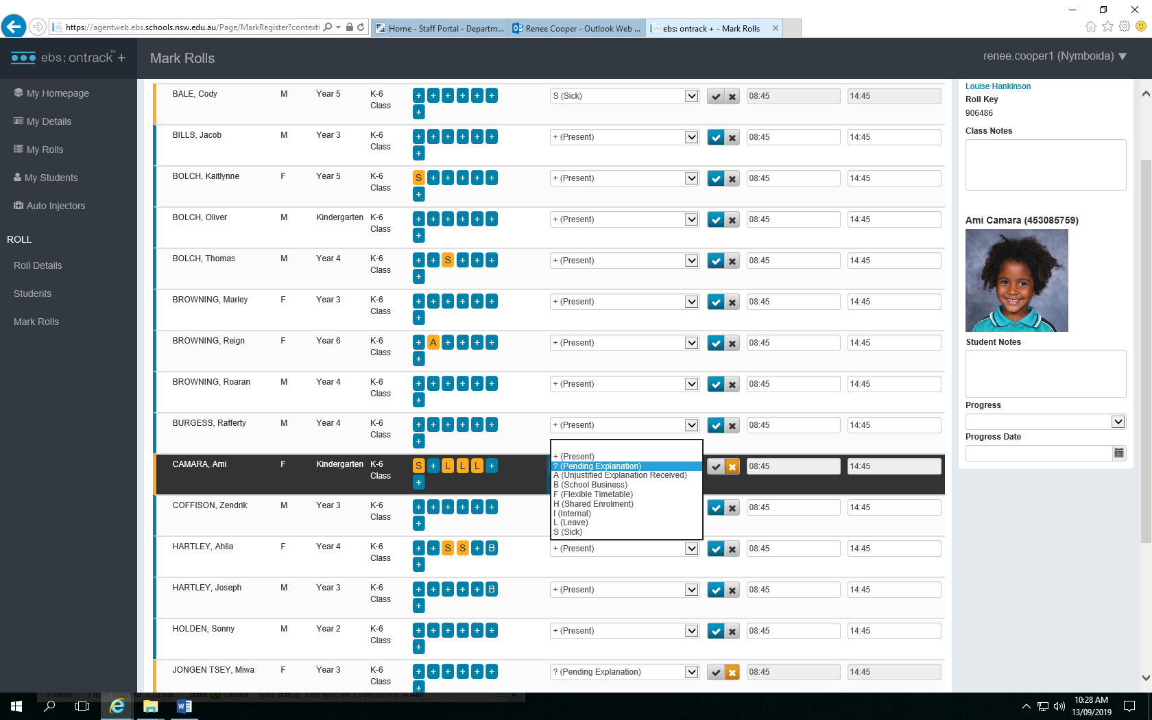

- Follow absences within 2/3 days.

- After 7 days mark all unexplained full day or partial absences with an A

APPENDIX B

- ATTENDANCE REGISTER CODES

Manual Attendance Registers Note: The symbol X is to be used for the first and last day that the student attended for each term.
Symbols to be used where students are absent from school
Symbol | Meaning
a | The student was absent on that day.
Pa | The student was late or was absent for part of a day. The time of arrival or departure must be recorded.
Symbols to be used for explanation of student absence
Note: The following symbols should be recorded above the a or Pa symbol as appropriate
Symbol | Meaning
A | The student’s absence is unexplained or unjustified. This symbol must be used if no notice has been provided by parents within seven days of the occurrence of the absence.
S | The student’s absence is due to sickness or as the result of a medical or paramedical appointment. In these cases:  - a medical certificate is provided or  - the absence was due to sickness and the principal accepts this explanation. Principals may request a medical certificate in addition to explanations if the explanation is doubted or the duration of the absence is more than four days.
L | Principals may record up to 15 days in a school year for students of compulsory school age who have provided an explanation of the absence which has been accepted by the principal. Additional days for students not of compulsory school age may be recorded at the principal’s discretion.  This symbol is recorded where a student’s absence is due to reasons accepted by the principal. This may be due to:  - misadventure or unforseen event  - participation in special events not related to the school  - domestic necessity such as serious illness of an immediate family member  - attendance at funerals  - recognised religious festivals or ceremonial occasions.
E | The student was suspended from school.

APPENDIX B

- ATTENDANCE REGISTER CODES

SYMBOLS TO BE USED FOR VARIATION IN ATTENDANCE
(not counted as a n absence for statistical purposes)
Symbol | Meaning
M | The student was exempted from attending school.
F | Senior student participating in flexible timetable not present because not required at school.
B | The student is absent from the school on official school business. This symbol is recorded where the principal approves the student leaving the school site to undertake:  - work experience  - school sport (regional and state carnivals)  - school excursions.
H | The student is attending two or more education settings for a period of time (shared enrolment). This symbol is recorded where a student accesses a specialist educational setting on a sessional or full-time basis in line with the Department’s Enrolment Policy (Enrolment of Students in NSW Government Schools: A Summary and Consolidation of Policy 1997).  The symbol is recorded where a student accesses education settings separate to their mainstream school such as:  - tutorial centre and programs  - behaviour schools  - juvenile justice  - hospital schools.

