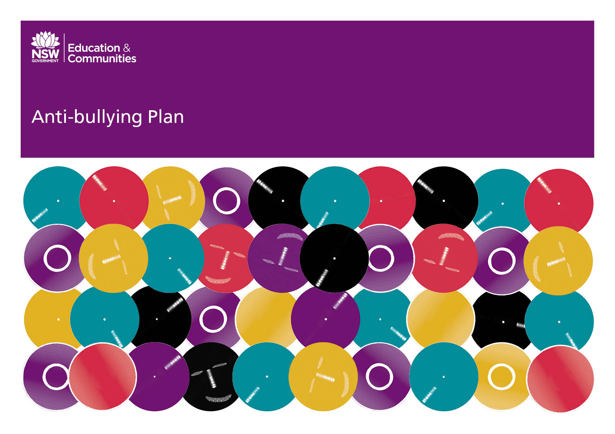

Nymboida Public School 2022 Update

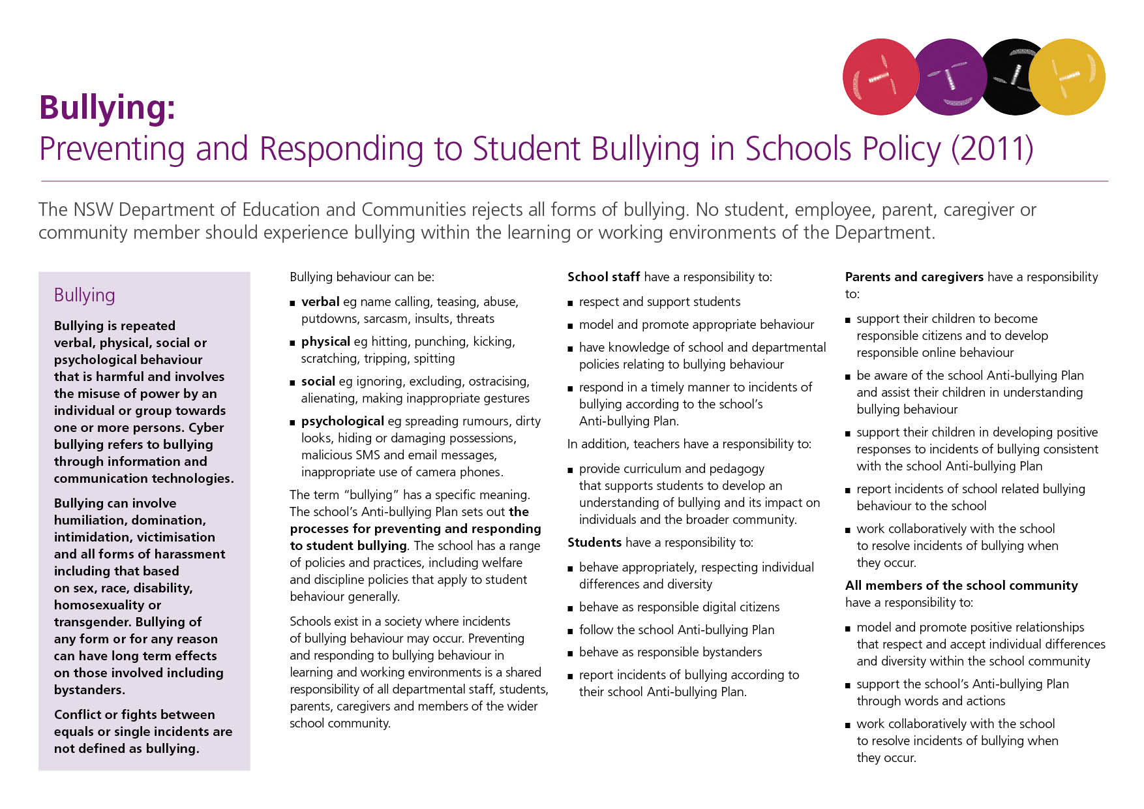
Our School Anti-Bullying Plan
Ask your child for the full story and what they may have done to the other child. Understand that when reported and investigated by the school, both sides of the issue will be considered. Understand the definition of bullying and not mistake it for single incidents or conflicts between equals.
Our School Anti-Bullying Plan
This plan outlines the processes for preventing and responding to student bullying in our school and reflects the Bullying: Preventing and Responding to Student Bullying in Schools Policy of the New South Wales Department of Education and Communities.
In 2017, staff, students and the community were engaged in establishing core values to support the positive behaviours of all students in our quality learning environment.
Nymboida Public School will collaborate with the school community in developing, implementing, evaluating and reviewing this plan through P&C meetings, formal and informal discussions and other school based meetings
Statement of purpose
Nymboida Public School is an inclusive environment, where diversity is celebrated and individual differences are respected.
Quality education allows students to meet their learning needs in a secure, safe and supportive school environment.
The focus of quality education is for students to learn and grow with confidence. Students develop best in schools where teaching and learning occur in a context of student welfare.
The wellbeing, safety and health of students are the cornerstone of all school policies, programs and practices.
Partnership with parents and the wider community is considered central to the success of addressing bullying when it occurs in our community.

Protection
Bullying must be taken seriously and is not acceptable in any form.
Students and teachers have the right to expect that they will spend the school day free from bullying, harassment and intimidation.
Bullying
- devalues, isolates and frightens
- affects an individual’s ability to achieve
- has long-term effects on those engaging in bullying behaviour, those who are the subjects of bullying behaviour and the onlookers or bystanders.
Teachers, students, parents, caregivers and members of the wider school community have a responsibility to work together to address bullying. Teachers, parents and other adult members of our school community have a responsibility to model positive behaviour for their children and other students in our school community. Such modelling involves positive interaction on a daily basis but also appropriate reactions when bullying occurs.
Any inappropriate behaviour that gets in the way of teaching and learning at the school and interferes with the wellbeing of students is not acceptable.
Identifying bullying
Bullying can be defined as intentional, repeated behaviour by an individual or group of individuals that causes distress, hurt or undue pressure.
Bullying involves the abuse of power in relationships. Bullying can involve all forms of harassment (including sex, race, disability, homosexuality or transgender), humiliation, domination and intimidation of others.
Bullying behaviour can be verbal, physical, social or psychological. Cyber-bullying involves the use of technology, including internet, computers or phones, or through social media sites, like Facebook. This is unacceptable and is against the law.

Bullying behaviour can be
- verbal eg name calling, teasing, abuse, putdowns, sarcasm, insults, threats
- physical eg hitting, punching, kicking, scratching, tripping, spitting
- social eg ignoring, excluding, ostracising, alienating, making inappropriate gestures
- psychological eg spreading rumours, dirty looks, hiding or damaging possessions, malicious SMS and email messages, social pages, inappropriate use of camera phones.
Prevention

The school will adopt a four-point plan to anti-bullying, which includes:
- Primary Prevention
- Early Intervention
- Intervention
- Post Intervention
Primary Prevention
- Maintenance of a positive PBL school climate that acknowledges that bullying does occasionally happen, however will not be tolerated within the school community. A focus will be maintained with:
  - classroom posters that identify what bullying is, the different types of bullying and strategies for dealing with bullying when it occurs.
  - Social skills lessons and posters to be displayed in classrooms
  - Lessons that focus on bullying conducted at the beginning of each term to reinforce forms of bullying and how to deal with issues that arise.
- Community awareness and input relating to anti-bullying, its characteristics and the schools’ programs and response. (e.g. weekly newsletter, parent forums, learning community program)
- Staff supervision of set area in playground.
- Ensure students know and understand what behaviour is acceptable in the school. (i.e. consistent classroom/school rules displayed in the school)
Early Intervention
- Students are to be encouraged to report bullying incidents involving themselves or others.
- Teachers regularly remind students to report incidents. Reporting is not ‘dobbing’.
- Parents are encouraged to contact the school if they become aware of a problem.
- Students are recognised for positive behaviours
- Teachers use a class and playground management plan if an incident of bullying occurs.
- Executive are alerted to incidents of bullying.
Intervention
- Once identified, the bully, victim and witnesses are spoken with, all incidents or allegations of bullying will be fully investigated.
- Consideration as to why the bullying occurred will be investigated. (e.g. The bigger picture or contributing factors)
- Both bully and victim may be offered basic assistance and support (i.e. outside school resources through counselling may be utilised if deemed necessary)
- A meeting of relevant persons is to be convened following identification of on-going bullying behaviour (Principal, class teacher, parents, students, Learning Support Team, School Counsellor). All issues relevant to the behaviour of the student are considered.
Post Intervention
Incidents of bullying will be documented electronically. Details of bullying incidents will be communicated to parents when behaviour letters are sent home.
- Possible consequences may involve:
  - Warning
  - Removal to the class supervisor or principal
  - Parental contact
  - Negotiated contract
  - On-going monitoring
  - Timeout from the class/ playground
  - Mediation sessions with the victim to reconcile differences
  - Development of an Individual Behaviour Program
  - Referral to external agencies
  - Class/group changes
  - Detention
  - Suspension
Advice…
…to be given to students who are being bullied
The student should be encouraged to –
- Tell the bully to stop. State quite clearly that the behaviour is unwelcome and offensive
- Seek help. Talk about the experience to someone who is trustworthy (student leader, class teacher, Principal, parent, peer).
- Report the bullying to a member of staff and feel confident that any incident can be resolved satisfactorily but remember to tell the full story.
Other ‘self protective’ strategies that might be suggested include:
- Staying away from the bully, or places where bullying occurs.
- Be with friendly, supportive friends.

…to be given to students who know someone else is being bullied

Students should be made aware that witnesses to bullying have a very powerful role to play.

Early intervention can defuse conflict situations before bullying sets in or gets out of hand.

Therefore, the following suggestions should be made:
- If possible, intervene as the bullying occurs by telling the bully to stop. This is very useful if the onlooking student has influence with the bully.
- Refuse to join in with the bullying.
- Support students who are being bullied – just standing by them can be enough.
- Tell an adult about the bullying.
- It is every student’s right and responsibility to report bullying whether it happens to oneself or to someone else.

The role of parents
The following suggestions are made to parents through print materials and at Parent Information meetings.

Take an active interest
- in your child’s social life
- in what is happening at school

Encourage your child
- to bring friends home
- to accept and tolerate differences in others

Build your child’s self-confidence
- by recognising and affirming his/her positive qualities
- by valuing him/her for who he/she is.

Discuss with your child
- the school’s expectations about behaviour
- ways to respond if their rights are infringed

Encourage constructive responses
- physical bullying or persistent teasing should be reported
- hitting back or retaliating with name -calling won’t solve the problem

Set an example
- be firm, but not aggressive in setting behaviour limits
- be positive in things you say and do
- be positive in responding to bullying – don’t overreact

Be alert for signs of distress
- unwillingness to attend school
- dropping off in academic performance
- damaged clothing and frequent loss of personal property
- loss of confidence and uncharacteristic mood changes
- withdrawal from social activities.

Act
- If your child is being bullied at school, report it to a teacher, or the Principal. Your report will be followed up.

Response

Students, friends, parents or other community members are encouraged to report any bullying behaviour to a teacher or the Principal as soon as possible. This will ensure that the matter is dealt with promptly and supports the person who is being bullied.
When a bullying incident is reported to the school, the Principal will follow up on the incident by interviewing the students involved and any bystanders. Following this a decision will be made regarding consequences for the bullying behaviours and parents or caregivers will be notified accordingly.
When a bullying incident has involved assault, threats, intimidation or harassment the Principal will contact the police.
In the event of an incident where a child suffers a physical or psychological injury and is deemed by the principal to be at risk of significant harm, the Child Wellbeing Unit and or Community Services will be contacted, as necessary.
Nymboida Public School staff and the Department of Education and Communities seeks to resolve difficulties, grievances and complaints in a prompt, impartial and just manner. While most complaints should be resolved informally with the relevant employee, there are provisions for the use of formal procedures depending on the nature and seriousness of the complaint. In each instance, the Complaints Handling Policy and guidelines will be followed.

Additional Information
Kids Helpline
1800 55 1800

Parent Line NSW
13 20 55

Police Youth Liaison Officer – Grafton
Principal’s comment
Nymboida Public School staff, P&C, students and parents work together to ensure that our school is a supportive, diverse and engaging learning environment where students feel confident to take positive risks.
To be reviewed: September 2024

Elycia Hoade Relieving Principal
Brett Worley Classroom teacher
Nadia Hartley P and C President
Chris Johnson School Administrative Manager

School contact information
Nymboida Public School
3890 Armidale Road
NYMBOIDA 2460
Ph. 66494137
Fax. 66494
nymboida-p.school@det.nsw.edu.au
www.nymboida-p.schools@det.nsw.edu.au

